EXP-:2

1. Use of appropriate command to determine your login shell.



SYNTAX- $echo $SHELL

The $SHELL variable contains the name of the default shell.This approach works in most cases,It is not reliable way since the currently running Shell may not be the default shell.

1. To find all available shells in your system type by using appropriate command.

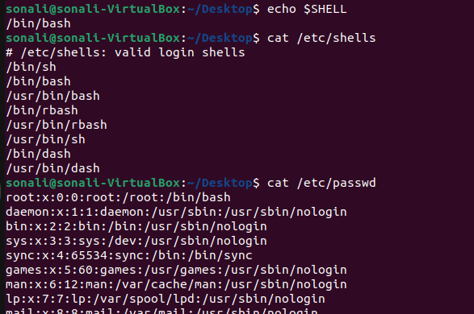

SYNTAX- $cat /etc/shells

To list available valid login shell for used at time.

1. Use the /etc/passwd file to verify the result of part (B).

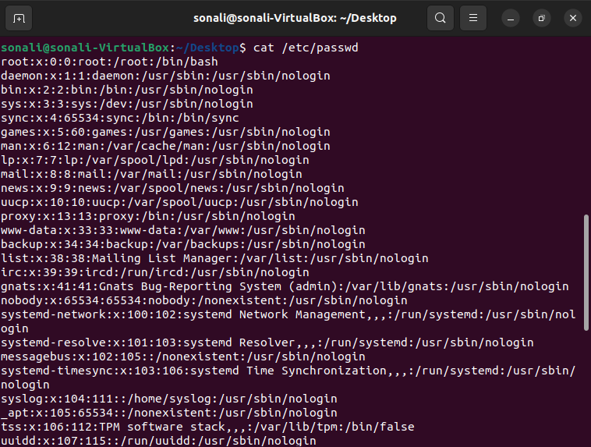

SYNTAX- $cat /etc/passwd

This file stores essential information required during logging. It is a plain text file containing a list of systems account and giving for each account some useful information. For example. ID, group ID, home directory, shell and more.

1. Use the date and who commands, in one line, such that the output of date is displayed on the screen and the output of who is redirected to a file. Use the more command to check the content of that file. 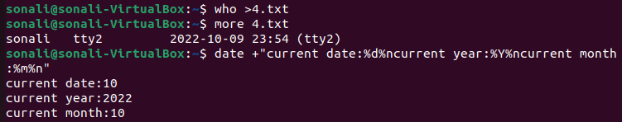

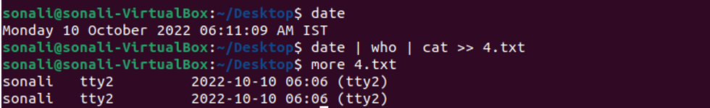

SYNTAX- $date +”%d %m %Y”

$who >file

$more file

1. Write a sed command that swaps the first and second words in each line in a file.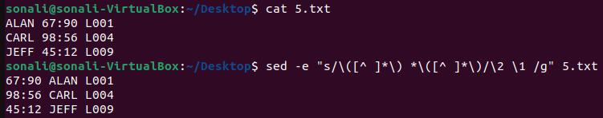

SYNTAX- $sed -e "s/\([^ ]\*\) \*\([^ ]\*\)/\2 \1 /g" file

Swap of first word with the second one in every line.

